**IoT based Smart Helmet to Enhance Rider Safety**

Battula Srinija, S B Adi Karthikeya, Ramineni S Goureesh, Sarda Sharma

*Department of Electronics and Communication Engineering*, Amrita School of Engineering,

Amrita Vishwa Vidyapeetham, Bengaluru, India

[srinija.battula@gmail.com](mailto:srinija.battula@gmail.com), [adikarthikeya1234@gmail.com](mailto:adikarthikeya1234@gmail.com), [rsgoureesh9@gmail.com](mailto:rsgoureesh9@gmail.com), [s_sarda@blr.amrita.edu](mailto:s_sarda@blr.amrita.edu)

**Abstract--In 2019, data from the World Health Organization indicated that motorcycle accidents contribute significantly to global road fatalities, highlighting the urgent need for improved rider safety measures. This research endeavours to develop an "IoT-Based Smart Helmet to Enhance Rider's Safety," integrating advanced technologies to enhance safety and emergency response. The smart helmet incorporates various sensors, including an accelerometer, GPS, GSM, and an alcohol detector, to provide real-time monitoring and alerts. The system leverages IoT capabilities to connect with a smartphone application, ensuring a user-friendly interface for continuous monitoring. Through accelerometer data, the helmet detects accidents and automatically sends alerts with the rider's location to predefined emergency contacts, facilitating swift response times. Additionally, the alcohol sensor prevents intoxicated riding, further ensuring rider safety. The smart helmet demonstrates an impressive accuracy and reliability in detecting emergencies, marking a significant advancement in protective gear for motorcyclists by potentially saving lives and reducing the severity of injuries sustained in accidents.**

**Key words: Crash detection; Alcohol detection; Live location tracking; Hands free communication and Smart Helmet**

1. INTRODUCTION

The thrill of riding a motorcycle is undeniable, but the inherent lack of protection compared to enclosed vehicles makes it a risky proposition. Statistics paint a grim picture – motorcycle accidents are a leading cause of serious injuries and fatalities. One of the most devastating consequences of these accidents is Traumatic Brain Injury (TBI). TBIs occur when a forceful blow to the head disrupts the normal function of the brain. Even seemingly minor accidents can cause TBIs, leading to a range of physical, cognitive, and emotional challenges. Beyond TBIs, motorcyclists are also vulnerable to fractures, internal injuries, and other life-threatening conditions.[1]

Given the high risk associated with motorcycle riding, it is imperative to enhance protective measures for riders. Traditional helmets provide a basic level of protection, but they do not address the myriad of risks motorcyclists face on the road [2]. This is where our project, the development of an IoT-based smart helmet, comes in. By integrating advanced technology, we aim to significantly reduce the risk and impact of motorcycle accidents.

Our smart helmet goes beyond basic protection; it becomes a proactive guardian, using sensors and communication to enhance rider safety and potentially prevent accidents altogether. The helmet includes features such as helmet detection, ensuring the rider is wearing the helmet before the vehicle starts; alcohol detection, preventing the vehicle from starting if alcohol is detected in the rider's breath; crash detection, automatically sending an emergency alert with GPS location to predefined contacts; an SOS button for immediate help; and speaker availability for navigation assistance and communication.

Through these innovations, our smart helmet not only aims to protect the rider in the event of an accident but also to prevent dangerous situations before they occur, thereby enhancing overall road safety. By ensuring helmets are worn, preventing drunk driving, enabling quick emergency responses, and offering navigation and communication support, the smart helmet addresses multiple aspects of rider safety. This comprehensive approach significantly enhances overall road safety, reducing the risk of accidents and improving outcomes when incidents do occur.

1. LITERATURE SURVEY

Kamdi introduced an innovative IoT-based intelligent and smart helmet for bike riders, utilizing Arduino technology to enhance safety measures.[3] The helmet integrates multiple sensors, including an accelerometer, gyroscope, alcohol sensor, and RFID for secure authentication, to detect accidents, monitor rider sobriety, and ensure authorized use. Sireesha introduced an IoT-based smart helmet aimed at enhancing motorcyclist safety in the study titled "Smart Helmet using IoT" [4]. This helmet system integrates sensors for alcohol detection, crash detection, and helmet wear detection, sending real-time alerts with GPS locations to emergency contacts.

Muneshwara M S’s paper reviews Advancements in wireless technology enhancing smart helmets for road safety [5]. Their research includes Wi-Fi, and cellular networks for real-time data transmission between smart helmets and other devices. The paper by Gurpreet Singh reviews the latest advancements in IoT-based smart helmets, discussing their design, functionality, and impact on road safety[6]. Researchers focus on preventing drunk driving and ensuring quick emergency response, significantly improving motorcyclist safety. S. Gupta introduced a paper titled "Implementation of Alcohol and Collision Sensors in a Smart Helmet" . The paper explores the integration of alcohol and collision sensors into a smart helmet [7].

However, as per the author’s knowledge the previous works does not include Emergency alert disable button, SOS button, live-tracking of the vehicle. Therefore, the goal of the current study is to deploy these features into the helmet and make a new model which sends real-time alerts such as SMS and call to registered contacts along with GPS locations during emergency, emergency alert disable button, live-tracking of the vehicle, SOS button, speaker availability, helmet, chin-strap, alcohol and crash detection features.

1. PROPOSED METHODOLOGY

The suggested methodology consists of 3 steps: System Design, Implementation, and Testing and Validation.

1. System Design:

The system design stage marks a pivotal juncture in the development journey of the smart helmet system, where comprehensive planning and architectural deliberation occur. This phase carefully designing the smaller parts including Helmet Usage Monitoring, Alcohol Detection, Speaker Availability, Emergency Services Activation, LCD Display, and User Interface and Feedback. Each component undergoes rigorous scrutiny to ensure alignment with user requirements, adherence to safety standards, and feasibility within technological constraints.

1. Implementation:

In the implementation stage, design specifications are transformed into tangible software, firmware, and hardware components. Firmware programming focuses on developing algorithms for sensor data processing and control logic, while software development involves creating user interfaces and applications for seamless interaction. Hardware integration includes mounting electronic components within the helmet, ensuring comfort and adherence to safety standards. Compatibility testing ensures smooth interaction with external devices like smartphones and motorcycles, while regulatory compliance validates legal and market readiness. Iterative refinement and stakeholder collaboration characterize the implementation stage, where constant feedback drives enhancements and mitigates risks.

1. Programming:

The smart helmet's programming uses a special type of computer language called Embedded C. This language is used to write the instructions for the helmet's microcontroller, which is like the helmet's brain. These instructions help the helmet to read data from its sensors, control the bike, and communicate with other devices. By using Embedded C, the helmet can quickly and accurately process information, send alerts, and perform various tasks to keep the rider safe.

1. *System Architecture*

The initial step in any smart helmet model is the system design. The system has two sections: Helmet and vehicle.

Helmet Section:

Fig.1 mentions all the components used in fabricating the smart helmet. All these are mentioned below along with their specifications and how they helping in implementing the smart helmet.

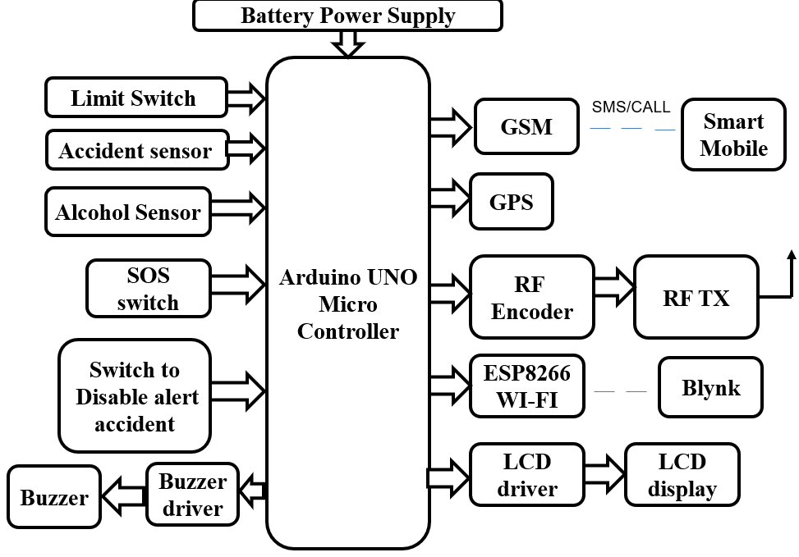

Fig.1: Schematic diagram of helmet section

Main components:

1. Arduino UNO:

The Arduino Uno is a microcontroller board which has ATmega328 from the AVR family. There are 14 digital input/output pins, 6 Analog pins and 16MHz ceramic resonator. USB connection, power jack and also a reset button is used.

1. Alcohol Sensor:

This module is made using Alcohol Gas Sensor MQ3. It is a low cost semiconductor sensor which can detect the presence of alcohol gases at concentrations from 0.05 mg/L to 10 mg/L.  This alcohol sensor is suitable for detecting alcohol concentration on your breath, just like your common breathalyzer.

1. ADXL345:

ADXL345 Tripple Axis Accelerometer Board is a small, thin, low power, 3-axis accelerometer with high resolution (13-bit) measurement at up to ±16*g*. Digital output data is format as 16-bit twos complement and is accessible through either an It measures the static acceleration of gravity in tilt-sensing applications, as well as dynamic acceleration resulting from motion or shock. Its high resolution (4 m*g*/LSB) enables measurement of inclination changes less than 1.0°.

1. GSM modem:

Global system for mobiles (GSM) is a globally accepted standard for digital cellular communication. Like any other mobile phone we are also interfacing GSM modem with our Microcontroller. The GSM modem used in the

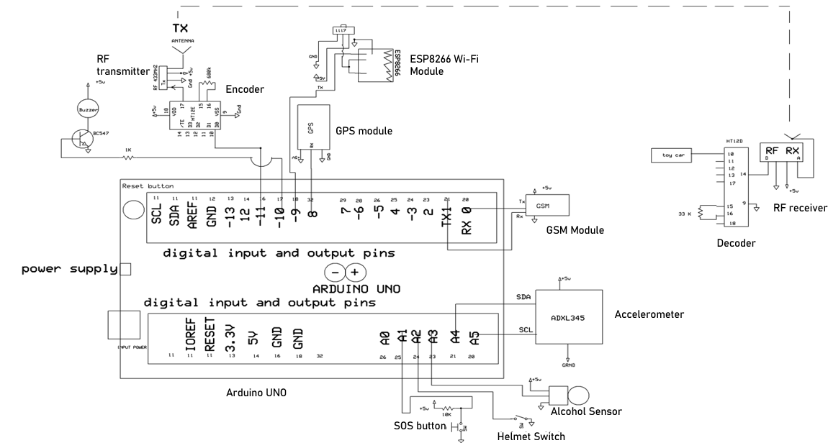

Fig.2: Circuit Diagram

project is SIM-900A. Specification. Dual-Band 900/ 1800 MHz.

1. RF transmitter and receiver:

RFtransmitter is an electronic device which uses radio waves for transmitting the signal. RF receiver is an electronic device which receives the data present in the radio waves and filters out unwanted data. It’s transmission channel: 434 MHz and range: 60 m.

1. Encoder and Decoder:

Encoder is used to generate the digital data which need to be transmitted. The encoder used in the project is HT12E. This encoder has 8-address lines and 4-data lines.

Decoder is used to decode the required data from the received data. The decoder used in the project is HT12D.This decoder has 8-address lines and 4-data lines.

1. GPS module:

GPS stands for Global Positioning System. The GPS provides continuous three-dimensional positioning 24 hours a day throughout the world. We used NEO-6M GPS Module for our project. It has 5Hz position update rate, rechargeable battery for backup and a supply voltage of 3.3 V.

1. Buzzer:

A buzzer is a audio signalling device which may be mechanical, electrochemical or electronic.

1. ESP8266(Wi-Fi Module):

The ESP8266 Wi-Fi Module is a self contained SOC with integrated TCP/IP protocol stack that can give any microcontroller access to your Wi-Fi network. The ESP8266 is capable of either hosting an application or offloading all Wi-Fi networking functions from another application processor

Vehicle Section:

Similar to Fig.1, Fig.3 also mentions the components used in making the vehicle model.

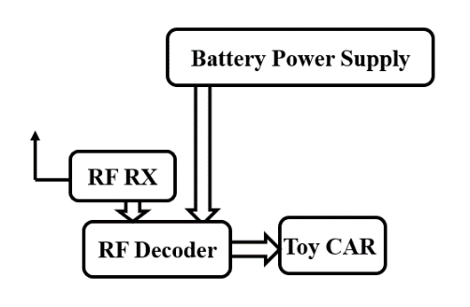

Fig.3: Schematic diagram of vehicle section

1. *Implementation*

Operational Workflow:

Fig.2 shows the connections and operational workflow of the helmet and vehicle module. The bike's ignition will activate only under the following conditions: the rider is wearing the helmet, the chin-strap is secured, and the rider's alcohol consumption level is below the set threshold value.

Once all the above mentioned conditions are satisfied, the LED of the toy car and microcontroller will turn on and these conditions status will be displayed on the LCD. The GPS module will track the live location of the sim card we input in the GSM module and displays it’s latitude and longitude on LCD as shown in Fig.4 and 5.

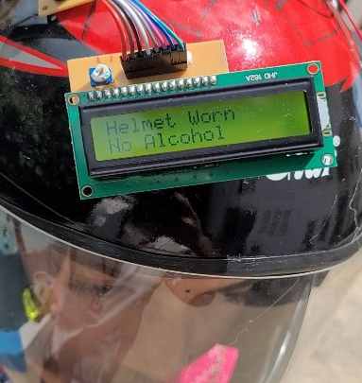

Fig.4: LCD display of helmet and alcohol detection

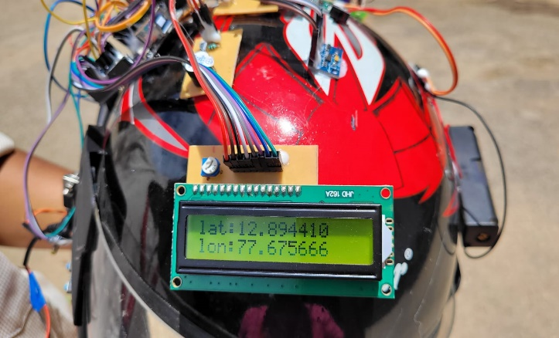

Fig.5: LCD display of location of the helmet

Helmet will detect any crash happened and sends a emergency alert (both call and SMS) to the registered contacts along with the rider’s location as depicted in Fig.6. A 10 seconds delay is introduced in this process, to turn off the emergency alert by using de-activation button in case of false alarm [8].

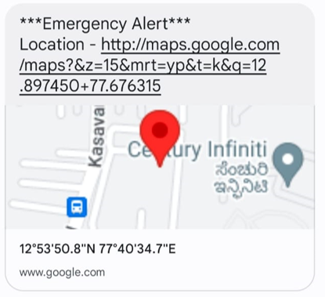

Fig.6: Emergency alert sent to registered contact

Fig.7 shows the live-location tracking of the vehicle in Blynk app in our mobile.

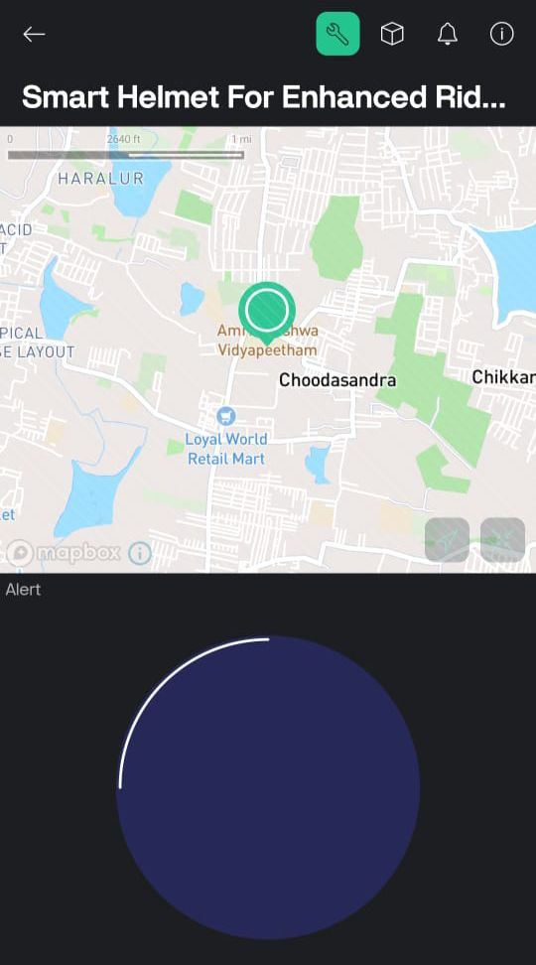

Fig.7: Live Location Tracking in Blynk app

SOS button and speaker features are available in this helmet. While feeling any threat/danger, rider can press the SOS button to alert the registered contacts via SMS. Speaker availability inside the helmet helps the rider to attend the calls without using mobile, therefore reducing the number of distractions and accidents.

1. *Programming*

The program was compiled and executed using Arduino IDE compiler application software of version 2.3.2 and made use of libraries like Adafruit_ADXL345, TinyGPS++ and Liquid crystal along with the Software Serial. Codes for helmet detection, alcohol detection, chin-strap detection, crash detection, SOS and Emergency alert disable buttons, sending real-time alerts and live-location tracking were written in Embedded C.

1. *Helmet Section*

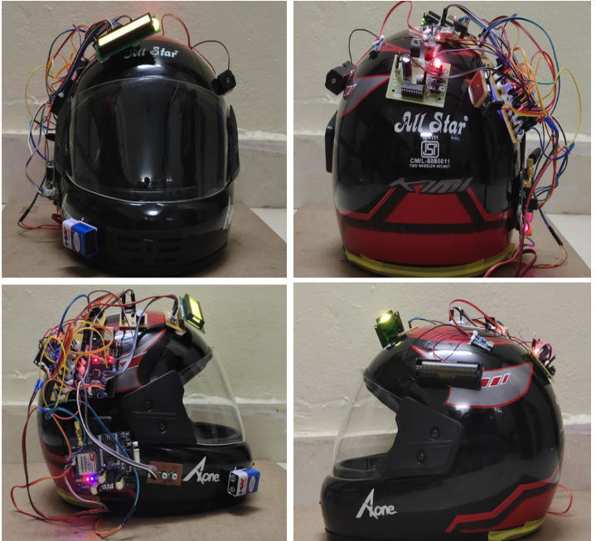

Fig.8.a: Helmet module – Front View



Fig.8.b: Helmet module – Back View



Fig.8.c: Helmet module – Right View



Fig.8.d: Helmet module – Left View

Fig 8.a to 8.d shows the final output of the helmet.

1. *Vehicle Section*

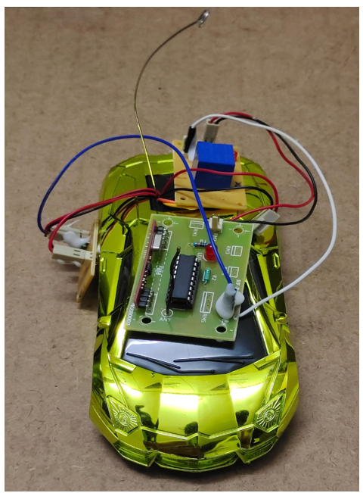

Fig.8: Vehicle Module

1. RESULTS AND DISCUSSION

The smart helmet project resulted in a highly functional helmet that enhances rider safety and communication. It integrates limit switch and strap sensors to ensure proper helmet use, a alcohol sensor to detect alcohol levels, and accident detection through accelerometers and gyroscopes, which can send GPS-based emergency alerts. The helmet includes speakers and a microphone for hands-free communication, prioritizing important calls to reduce distractions. It provides both audible and visual alerts through a buzzer and LCD display. With internet connectivity via the ESP8266 Wi-Fi module, the helmet allows for remote monitoring and additional features. Overall, the smart helmet represents a significant advancement in rider safety technology.

1. CONCLUSION

In conclusion, the smart helmet effectively enhances rider safety by using advanced technology to ensure proper helmet use, detect alcohol levels, and respond to accidents. It offers hands-free communication and real-time alerts to keep riders informed. This smart helmet marks a significant step forward in making motorcycling safer.

1. FUTURE SCOPE

In the future, we can include face recognition technology to improve security. This feature will ensure only authorized users can start the bike, reducing theft and preventing unauthorized use. This upgrade will make the helmet even safer and more advanced.

1. ACKNOWLEGMENT

We are grateful to our project guide, Dr. Sarda Sharma, for her support during the project and her valuable assistance in significantly improving our manuscripts.

1. REFERENCES

[1] M. E. Alim, S. Ahmad, M. N. Dorabati and I. Hassoun, "Design & Implementation of IoT Based Smart Helmet for Road Accident Detection," *2020 11th IEEE Annual Information Technology, Electronics and Mobile Communication Conference (IEMCON)*, Vancouver, BC, Canada, 2020, pp. 0576-0581, doi: 10.1109/IEMCON51383.2020.9284820.

[2] R. S. Krishnan, R. A. Lakshmi, P. Kalyanakumar, K. Jeyakumar, S. Sundararajan and K. L. Narayanan, "IoT based Smart Helmet for Safe Driving," 2022 6th International Conference on Electronics, Communication and Aerospace Technology, Coimbatore, India, 2022, pp. 485-490, doi: 10.1109/ICECA55336.2022.10009131.

[3] R. . Kamdi, R. . Vaidya, D. . Borakhade, P. . Thakre, A. . Nilawar, and V. . Panchbhai, “An IoT Based Intelligent and Smart Helmet for Bike Riders Using Arduino”, *Int J Intell Syst Appl Eng*, vol. 12, no. 10s, pp. 354–359, Jan. 2024.

[4] Guntupalli Sireesha, K. Baby Satya Jahnavi, Anusha N, Ayusha Baburay, 2020, Smart Helmet using IoT, INTERNATIONAL JOURNAL OF ENGINEERING RESEARCH & TECHNOLOGY (IJERT) NCETESFT – 2020 (Volume 8 – Issue 14)

[5] M. M S, A. R, S. T, S. M S and C. A. S, "Advanced Wireless techniques to avoid accidents on roads through wearing Smart helmet," *2021 5th International Conference on Intelligent Computing and Control Systems (ICICCS)*, Madurai, India, 2021, pp. 258-264, doi: 10.1109/ICICCS51141.2021.9432193.

[6] G. S. Chhabra, M. Verma, K. Gupta, A. Kondekar, S. Choubey and A. Choubey, "Smart Helmet using IoT for Alcohol Detection and Location Detection System," *2022 4th International Conference on Inventive Research in Computing Applications (ICIRCA)*, Coimbatore, India, 2022, pp. 436-440, doi: 10.1109/ICIRCA54612.2022.9985543.

[7] S. Gupta, K. Sharma, N. Salvekar and A. Gajra, "Implementation of Alcohol and Collision Sensors in a Smart Helmet," *2019 International Conference on Nascent Technologies in Engineering (ICNTE)*, Navi Mumbai, India, 2019, pp. 1-5, doi: 10.1109/ICNTE44896.2019.8945979.

[8] H. Chauhan, R. Rizwan and M. Fatima, "IoT Based Fall Detection of a Smart Helmet," 2022 7th International Conference on Communication and Electronics Systems (ICCES), Coimbatore, India, 2022, pp. 407-412, doi: 10.1109/ICCES54183.2022.9835890.

[9] N. V. Joshi, S. P. Joshi, M. S. Jojare, N. S. Joshi and A. R. Askhedkar, "Design and Finite Element Analysis of IoT based Smart Helmet," *2020 IEEE International IOT, Electronics and Mechatronics Conference (IEMTRONICS)*, Vancouver, BC, Canada, 2020, pp. 1-8, doi: 10.1109/IEMTRONICS51293.2020.9216393.

[10] M. A. Rahman, S. M. Ahsanuzzaman, I. Rahman, T. Ahmed and A. Ahsan, "IoT Based Smart Helmet and Accident Identification System," *2020 IEEE Region 10 Symposium (TENSYMP)*, Dhaka, Bangladesh, 2020, pp. 14-17, doi: 10.1109/TENSYMP50017.2020.9230823.

[11] Torad, Mohamed A.. (2021). Smart helmet using internet of things. International Journal of Reconfigurable and Embedded Systems (IJRES). 10. 90. 10.11591/ijres.v10.i2.pp90-98.

[12] M. J. Islam, M. N. Pathan, A. Sultana and A. Rahman, "An IoT-Based Smart Helmet for Riding Security and Emergency Notification," 2024 6th International Conference on Electrical Engineering and Information & Communication Technology (ICEEICT), Dhaka, Bangladesh, 2024, pp. 1211-1216, doi: 10.1109/ICEEICT62016.2024.10534489.

[13] Somantri and I. Yustiana, "Smart Helmet Integrated with Motorcycles to Support Rider Awareness and Safety Based Internet of Things," 2022 International Conference on ICT for Smart Society (ICISS), Bandung, Indonesia, 2022, pp. 01-05, doi: 10.1109/ICISS55894.2022.9915262.